Case Study 2: Santo Niño – Part I
Identifying and prioritising problems with farmers

A research team was invited to work in the villages around the town of Santo Niño in the Philippines. The provincial government was concerned with the increasing erosion and felling of trees by smallholder farmers, who form the majority of farmers in the area.

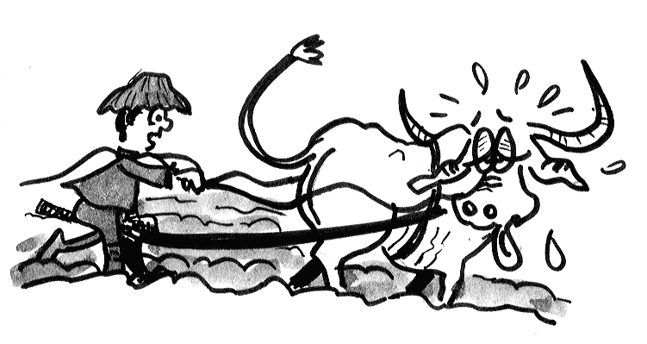
On their first visit, the team observed that farmers were intensively cultivating many scattered small plots, while most of the surrounding land was in fallow. Few trees remained and most of the land was covered by a weed (Imperata cylindrica) locally know as Cogon. Many small plots were on steep slopes, where heavy clay soils were exposed to intensive rainfall after the cassava harvest. These infertile soils (low in P and organic matter) were planted by smallholder farmers with upland rice. Farmers used no fertilisers and obtained very low rice yields. They planted cassava after the rice harvest, and then left the land fallow. Most farmers kept at least one buffalo, but these animals were poorly nourished, suffering from parasites, and often too weak to plough the heavy soils.

During informal interviews with local farmers the team discovered that even though farmers realised their own land was eroding, they could not obtain access to better quality land because they lacked cash to rent it from the landlords. Farmers complained about the shortage of labour and draft animals, which made it very costly to prepare the land.

The team decided to hold a meeting at which farmers could discuss their problems. Twenty farmers from Santo Niño attended the meeting. At the meeting the research team made a list of the problems farmers felt were most important. In order of importance, these were:

- The lack of cash and credit.
- Declining yields and infertility of the soil.
- The infestation of Cogon weed (Imperata cylindrica).
- Difficulty of preparing fallow land.
- The amount of time spent in weeding.
- Non-ownership of land.
- Diseases of animals.
- Their own health.
- Lack of ploughs.
After hearing about these problems, the research team carried out an informal survey in Santo Niño and three other villages (16% of the population were interviewed). They learned that 22% of the land was irrigated for lowland rice, and that this land was owned by smallholder farmers. Another 42% of the land was in fallow, 55% of the farmers had fallow land dominated by Cogon (Imperata cylindrica). The team estimated the annual incomes of these smallholder farmers at US$160. The cost of preparing one hectare of land by hand or with animal traction ranged from $30-$50 per hectare. 68% of farmers owned a buffalo.

For land preparation, approximately 20 days were spent on ploughing with buffalo at a total cost of $30 per hectare followed by a further 30 days of manual labour. 70% of farmers prepared the land entirely by hand. This involved cutting, chopping, gathering and burning two times, totalling 110 days of labour costing $30 per hectare. All farmers weed their plots manually. Plots infested by Cogon required 60 days/ha of manual weeding, at a cost of $20/ha.

After completing their initial diagnosis, the researchers drew up a list of possible problems for research. Faced by the wide variety of difficulties and constraints, the researchers felt confused about which problem to study first and they asked the farmers in Santo Niño to meet with them again.

At this meeting the researchers asked the farmers to help them make a drawing to represent what was happening on their farms.

The picture drawn by the farmers showed that yields of rice and cassava were going down over time because the soil became less fertile due to continuous cropping on the same plot. Another reason for the decreasing yields was erosion, which occurred whenever it rained heavily. Erosion was especially bad because soils were exposed to the rain for long periods of time when plots were being cleared. The Cogon seed blew in and rapidly germinated on the exposed, infertile soil. This made it even more time-consuming to prepare the land for planting. Yields were also low because it was difficult to weed poorly-cleared plots infested with cogon weed. Poor health in the family meant labour was scarce, so weeding and land preparation took a long time to complete. There was little cash to hire labourers or draft animals. The buffalo were often too weak to do the ploughing, except very slowly. Because they had little cash, the farmers could seldom rent better land, and so had to continue planting a few plots intensively.

Low Yields
Low soil fertility
Continuous cultivation
Cannot rent good land
Erosion
Heavy rain

Difficult to weed
Shortage of labour

Poor human health

Lack of cash
Poor animal health

Shortage of draft animals

Rapid infestation of Cogon

Difficult land preparation

Soil exposed during land preparation

After discussing the drawing representing their situations, the farmers and researchers were able to reach agreement on a priority problem for the team's research in the community.

Questions for Part I:

- Which problem do you think the farmers identified as having the highest priority? Why?

- How does the degree of farmer participation in this example compare with the Claveria case study?

- What would you have done differently if you were in charge of the team?

Case Study 2: Santo Niño –Part II
Identifying Options to test

Once they had analysed the problem and its causes, the farmers of Santo Niño and the researchers agreed on the need to eliminate Cogon. But, what to do precisely, and how to do it? There was no shortage of ideas. Some farmers thought that Cogon could be controlled by modifying certain physical conditions. Others preferred other changes, but they could not reach any agreement.

The farmers then asked themselves who in the area, or outside it, was doing anything similar to what they had proposed. To answer this question, it was necessary to visit the farms in the area again, contact knowledgeable people in the locality, and discuss possibilities. In this way, they began to answer their questions about what to experiment with, where, and how.

In the new visits to the farms, the researchers observed several interesting experiments, which farmers were conducting on their own. Several local farmers had observed that Cogon growth was inhibited when shaded or when competing with vigorous plants. Most of the farmers knew that Cogon did not grow in shady areas and did not germinate in shaded or covered soils. The farmers gave more ideas for controlling Cogon, such as changing the method of ploughing or planting cassava and sugarcane. The researchers suggested the use of herbicides. All these proposals were presented to the entire group of farmers so that they could decide on what they would like to test.


Farmers and researchers discussed the advantages and disadvantages of the proposed alternatives. Some alternatives, such as ploughing or applying herbicides, offered potential solutions to the physical causes of the problem, but were impractical given constraints such as lack of money and manpower. However, the idea of shading the Cogon by planting forage trees or climbing legumes did not seem to be in conflict with these limitations and the farmers and researchers agreed to test it.

Questions
- What did the farmers identify as the most important problem?

- What technologies were offered to the farmers?

- Which ones did the farmers agree to evaluate?

- What did the researchers and the farmers each contribute to identifying the causes of the problem?

- What were the roles of researcher and farmers in the process. How do these differ from their role in conventional approaches to technology development?

